BLUE COLLAR LONDON

Stop #1 – Story 24 – Harold Westhead, Labatt Brewery
Stop #2 – Story 19 – Chris Andreae, London Soap Company Monument
Stop #3 – Story 25 – Jim Payne, Canada Bread Factory

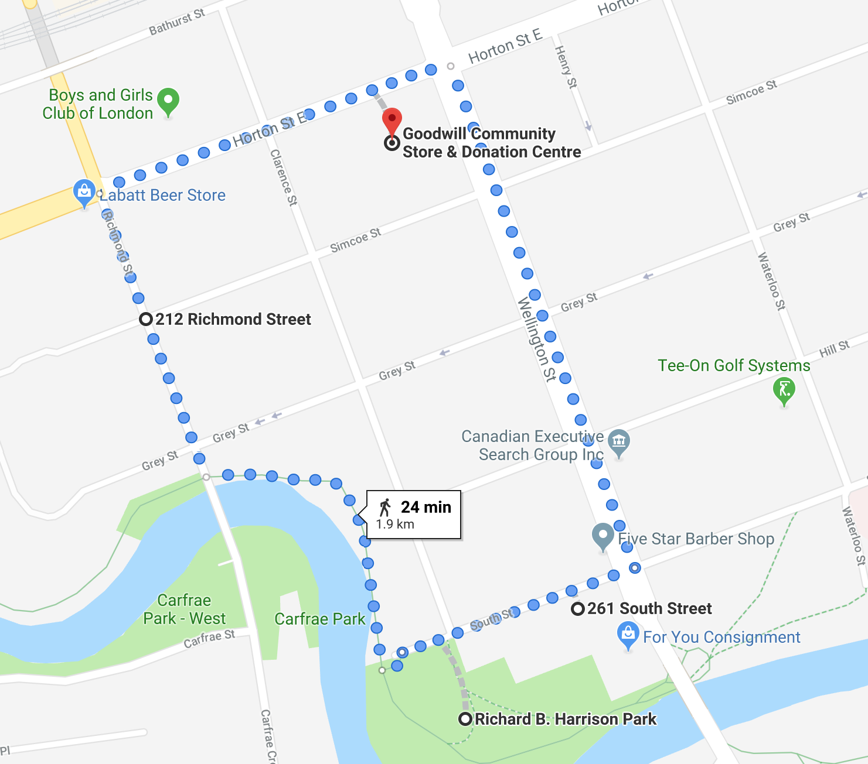

Introduction
The SoHo – or South of Horton – neighbourhood has existed here in London since the city’s inception in 1840. The neighbourhood, originally named St. David’s Ward, is bordered by the CN rail track on the north, Adelaide Street on the east, and the Thames River on the south and west sides. Because of its proximity to the rail lines and the Thames River, SoHo became an industrial area of the city with affordable housing and a strong network of local business and commercial corridors.
Today we will be visiting three industrial sites, or former industrial sites, of London’s SoHo. The walk will be about 25 minutes with the entire tour running about 40 minutes. We will be returning here to Goodwill once the tour is finished.

Goodwill to Labatt’s (6 minutes)
To start, we will be making our way down Horton Street to turn left down Richmond Street to our reach our first location.

At Labatt’s (Stop 24)

The Labatt Brewery was opened in 1847 on Simcoe Street here in London by John Kinder Labatt. The original brewery could produce about 1,000 bottles of beer per year. Today, that number is close to 700 million bottles per year. In 1847, John Labatt purchases the Simcoe Street Brewery in partnership with Samuel Eccles. In 1853, Labatt became the sole owner of the brewery and renamed the company as Labatt’s Brewery. There were six men on Labatt’s payroll at that time.

Today Labatt Breweries operates breweries across Canada, employing over 3,000 Canadians and selling over 35 million cases of their 50 varieties of beer annually. The London Brewery here at Richmond and Horton employs around 650 Londoners today.

The story you will hear here is from Harold Westhead, who began working at Labatt’s in 1934.

Labatt’s to Harrison Park (7 minutes)
We will now be making our way down to Richard B. Harrison Park to hear our next story. It’s about a 7 minute walk.

Harrison Park (Stop 19)

The London Soap and Cosmetic Company once stood here at 197 South Street. The Soap Company began production in 187e, providing soap throughout the Dominion of Canada. When the company shuttered in 1980, it was one of Canada’s longest operating factories. In the early 1980s, the City of London received a proposal to transform the London Soap Company into a museum however that plan was extinguished when a fire tore through the building in April 1985, burning it to the ground. A year later, in April 1986, the Ontario Society for Industrial Archaeology erected a monument to the factory here in the park where the building once stood.

As Chris Andreae describes in his story here, the factory building was rarely renovated or added to through its lifetime and the machinery remained an excellent example of 19th century manufacturing.

Harrison Park to Bread Factory (2 minutes)
We will now take a quick walk down South Street to our next location.
Bread Factory (Stop 25)

The empty lot here at 258 South Street was once home to a branch of the Canada Bread Company. Canada Bread was still producing fresh breads and rolls for retail and food-service customers when the Toronto-based company decided to close the London plant in July 2003, citing the age and limited size of the factory as reasons for the closure. The closure put 181 Londoners out of work.

In his story, Jim Payne describes his memories of following in his family’s footsteps, becoming a baker at the Canada Bread Company.

Bread Factory to Goodwill (9 minutes)

Thank you for joining us on this tour! We hope you enjoyed listening to the stories of SoHo’s industrial heritage. Be sure to keep an eye out for more Hear, Here signs throughout SoHo. All of the Hear, Here stories available on the phone system, are also available on our website: hearherelondon.org. We will now make our way back to Goodwill - about a 9 minute walk - where you can take more of today’s upcoming tours if you wish.

Goodwill

