South Street Hospital Tour
Katie Anderson

Begin: Goodwill, 255 Horton Street
Stop: #1: Marilyn Austin, Gartshore Nurses Residence, 370 South Street
Stop #2: Dave Moczulski and Matthew Trueman, Bus Stop #2276 South Street Hospital
End: Goodwill, 255 Horton Street

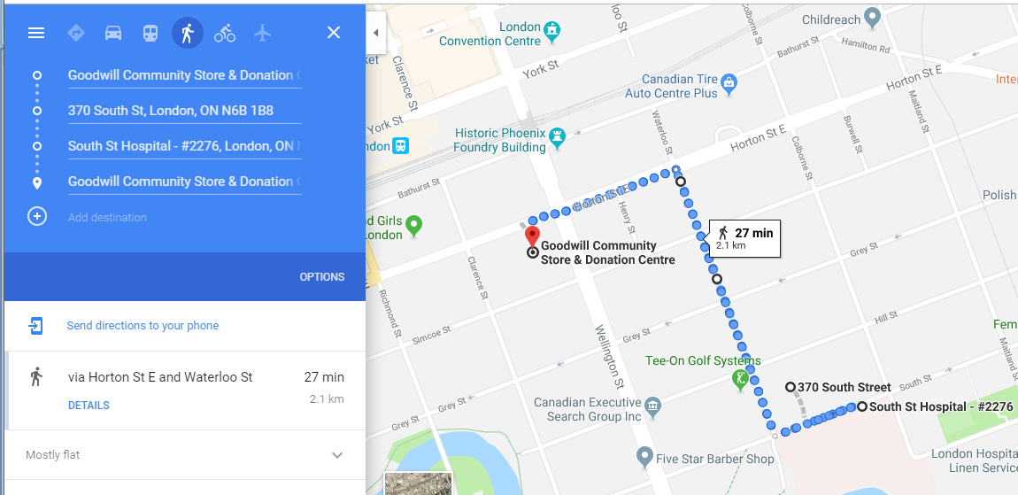

Introduction at Goodwill:
You don’t have to be a resident of SoHo to be familiar with South Street Hospital. The hospital, originally known as the old Victoria Hospital, existed for almost 140 years. The first version of the hospital was built on the South Street lands in 1875, evolving and expanding until finally closing its doors in 2013. The hospital had a central place in the lives of many Londoners, some who worked there as nurses and doctors, those who attended the Medical School or lived at the Gartshore Nurses Residence while attending the Nursing School, and the numerous children treated at the War Memorial Children’s Hospital. Many people have a significant memory associated with the hospital, whether due to the birth of a child, being treated for a serious illness, or the death of a family member. For others, simply walking past the monumental building was part of their daily lives.

Today, you will hear three very different stories related to the South Street Hospital, all of which show the extent to which the hospital impacted the daily lives of Londoners. We are going to hear stories from a nurse who attended the Nursing School, a member of the Polish community who lived and grew up beside the South Street Hospital, and a London photographer who captured the final days of the hospital as it was being demolished.

Instructions: Our first stop is about a 12 minute walk from here. Our route we be down Horton Street, right onto Waterloo Street, until we reach South Street where our stops will be.

Stop #1: Marilyn Austin
Currently we are standing outside the Gartshore Nurses Residence, built in 1927, and as you can see from the boards and construction, it is scheduled for demolition. We will hear a story from a woman named Marilyn Austin who attended the Nursing School and resided at the Gartshore in the 1960s. I had the opportunity to interview both Marilyn and Tom Austin, as Tom attended the adjacent Medical School. Both have had a long association with South Street Hospital throughout their careers, and even today they have many pieces of art depicting the hospital in their Wortley Village home.

This is one of many stories about the South Street Hospital Marilyn reminisced during her oral history interview. Marilyn’s time at the the Nursing School may have happened in the 1960s, but as you will hear, her experiences first entering the school is very relatable to students going off to university today.

Instructions: To hear Marilyn’s story, take out your mobile phone and call 1-519-672-4327 x26.

Follow up to Marilyn’s story: Again, this was just one of many stories Marilyn told of her Nursing experiences that is part of the Hear, Here project. If you head down to the old Victoria Tavern, you can hear Marilyn’s story of when she and a few friends in the Nursing program got caught by the police for being underage at the tavern. Across the road, where we are headed next, you can hear about her experiences wheeling children back and forth through the old underground tunnel system, which connected the War Memorial Children’s Hospital to the main hospital.

Instructions: For our next story, we will be crossing the road to the bus stop beside the old Colborne building.

Stop #2: Dave Moczulski and Matthew Trueman
We are currently standing at the empty lands where the South Street Hospital used to be. All that remains of the original hospital on the south side of the street is the old Colborne building, built in 1899. At this stop, we will actually be listening to two stories. These stories will be played back to back, and I will give you all the instructions how to transition from one to the other.

The first story we will hear is from Dave Moczulski, a member of the Polish community in SoHo who related many memories of childhood during his interview. Dave grew up in a house on Colborne Street across from the hospital, and therefore witnessed a lot the bustling activity on South Street. In this story, he remembers the efforts made by the Salvation Army to boost the morale of the kids residing at the War Memorial Children’s Hospital.

The second story you will hear is by Matthew Trueman. Matthew is a London artist and photographer who documented the demolition of the South Street Hospital with stunning photographs, from when the demolition first began to its final days in 2015. His work has been featured in both an exhibition and local history book, written by author Ryan Craven, titled So Long South Street. As you will hear, Matthew’s observations about the Hospital are remarkably profound.

Instructions: You will call 1-519-672-4327 x27 to hear the first story by Dave Moczulski. After the first story ends, you will be given a prompt, and you will need to press “2” on your phone to continue to Matthew Trueman. You will need to do this quickly, because it will time out!

Conclusion
I wanted to conclude this tour with Matthew’s story, because I think his words truly demonstrate how woven the hospital was into the fabric that has made up the SoHo, and greater London, community.

During the past few months of research and speaking with many Londoners connected with South Street, to quote Matthew, it is evident that for many people, this hospital was very meaningful for them. I know in its current state that even walking down South Street, seeing the empty land and construction, is difficult for some people. There are many people who have told me they avoid coming here altogether, because it is just too painful. In the coming months, this space will continue to transform. But this is one of the main goals of the Hear, Here project, that even though the buildings themselves may no longer be part of the community, the stories from people who lived and experienced these spaces will be preserved. I think the three stories I shared with you today all demonstrate a varied aspect of the what the hospital meant for the community, but the truth is the number of stories that could be on these poles is endless. If you too have a story about the hospital, we encourage you to go to our website, hearherelondon.org, and share your memories. All the stories that are currently part of the Hear, Here London project can be listened to from the website.

Thank you for joining us today! I will be heading back to Goodwill, where you are welcome have more refreshments, explore more of SoHo by attending another tour, or stay to hear closing remarks.

(Depart back to Goodwill).

