COLLABORATIVE LABOUR IN SOHO

Hetty Roi

Stop #1 – Story 25 Jim Payne (261 South St.)
Stop #2 – Story 24 Harold Westhead (212 Richmond St.)
Stop #3 – Story 21 Peter Karas (195 Horton St.)
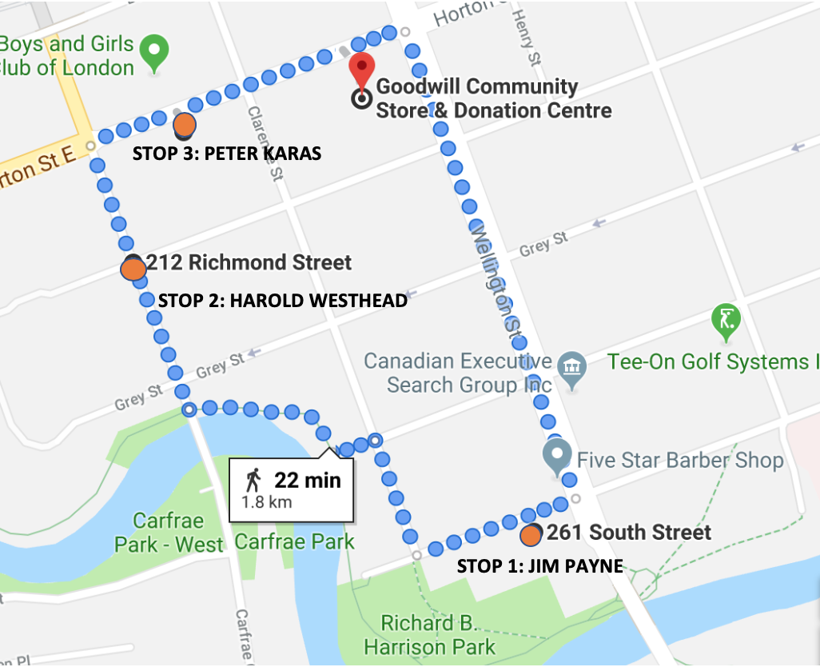
Introduction:
This tour will be looking at some instances of collaborative labour in the South of Horton neighbourhood in London.

Before we begin walking please pull out your phones and put in the Hear, Here London phone number: 1 519-672-4327

This tour will include about 22 minutes of walking and will take about 30 minutes overall to allow for time to listen to the stories.

While we walk to our first stop I will be introducing the tour.

London’s labour history has strong connections to the railroad which passes through the SoHo neighbourhood. The completion of the Great Western Railway in the 1850s prompted factories to spring up all around the SoHo area. Factories in this part of town often lasted for decades but were still sometimes subject to closures following greater trends in the London area. These closures were often associated with the age of the facilities. Industries in SoHo also felt the effects of mechanization and a changing workforce.

SoHo is also a place that showcases other forms of labour as well. Community work has allowed for the completion of many projects in the neighbourhood. The labour of people within this area is not just linked to industrial sites but is in fact visible in everyday spaces.

We will be hearing three stories along this tour that span decades from the 1980’s to the present. To start we will look at the old Canada Bread Factory lot and hear about different types of labour there. Following that, we will proceed to the Labatt Brewery continuing our examination of labour in factories. Our final stop will be at the London Community Woodshop to look at one of the products of collaborative work work within the community.

Some helpful things to keep in mind along the tour and while listening to the stories:
- What does collaborative labour mean to you?
- How often do you engage in collaborative work in your day to day lives?
- How do narrators use the words “we” and “I” when referring to their work?
- When is collaborative work not helpful?
- What kinds of collaborative work do we forget about?

(8 minute walk from Goodwill to 261 South St.)

Stop #1: Jim Payne (Story #25 at 261 South St.)

A bread factory stood at this lot for many years until the closure of Canada Bread in 2003. The lot was originally a family bakery, Johnston’s Brothers Bakery, that included an attached grocery on Wellington Street. Johnston Bros. is visible in city records dating back to 1881.

Canada Bread eventually took over from Johnston Bros. and was a staple for bread delivery with their horse-drawn truck that would drive around town. The factory continued to update equipment but was eventually closed because of the age of the plant. This closure affected 181 employees.

In this story, Jim Payne, who used to work at Canada Bread, reflects on his time as a baker and details a visit he made to the factory some years after leaving.

Please call the Hear, Here number and enter story number 25.

STORY

Directions: We will now continue along South St. until Clarence and we will be heading towards Richmond St.

(8 minute walk from 261 South St. to 212 Richmond St.)

Stop #2: Harold Westhead (Story #24 at 212 Richmond St.)

Labatt Brewery, opened in 1847, is a London, Ontario staple. The Great Western Railway was key to Labatt’s expansion. Currently the company employs 3, 400 employees across Canada. The London location alone employs 650 people. As a company, Labatt’s has never shied away from innovation. The company enjoyed a successful expansion across Canada and has also incorporated new technologies into the manufacturing process.

Harold Westhead’s story details his time spent working at Labatt. This story stop will be outside near the current Labatt Brewery. Westhead started his job there in 1934.

Please call the Hear, Here number and enter story number 24.

STORY

Directions: For our last stop we will head up to Horton St. and turn right.

(3 minute walk from 212 Richmond St. to 195 Horton St.)

Stop #3: Peter Karas (Story #21 at 195 Horton St.)

The London Community Woodshop is a relatively new addition to Horton St. Thanks to Pathways Skill Development this originally empty building is revitalized by the addition of a space for people to enhance their woodworking skills.

This mural is part of the revitalization process. Commissioned by Pathways and created with donated paint from Dulux and with help from the Ivy residence students next door, this is truly an example of a community effort.

We’ll now listen to Peter Karas’ story. As one of the artists who designed and painted the mural this story will give us a better understanding of what the painting process was like.

Please call the Hear, Here number and enter story number 21.

STORY

Directions: We’ll now take a short walk along Horton St. back to Goodwill for the conclusion of the launch.

(2 minute walk from 195 Horton St. to Goodwill)

Conclusion:
Thank you for joining us for a look at collaborative labour in the SoHo neighbourhood. We examined the ways in which collaboration can take shape. We looked at when collaboration can be helpful and when it can complicate the working process.
We began with Jim Payne’s story about the changing workforce. This story showcased the ways in which collaborative work can create gaps in efficiency. The second story, from Harold Westhead, allowed us to understand what kinds of teamwork are lost when workplaces switch to automated systems. Finally, in Peter Karas’ story we saw how collaboration can take many forms. Volunteers, suggestions and community voting allowed for what is now a beautiful mural.

Consider again some of our questions from the beginning:
- What is your understanding of collaborative labour?
- What types of collaborative labour are forgotten about?
- And what types of labour were not present on this tour or in these narratives?

There are a few closing remarks to be made at Goodwill which you are welcome to stay for. There are also plenty of other stories around the neighbourhood for you to visit if you wish. All of our stories can also be accessed at the hearherelondon.org website (spelling).

