A Place to Belong

Tour Delivered by Heather Wilson

Story 1 Sansone Fruit Company: Jean Hough #1 (Bus stop 977 east of Waterloo/Horton intersection, north side of street)

Story 2 Grey and Maitland track crossing: Jean Hough #2 (First pole east of Grey/Maitland intersection, north side of street)

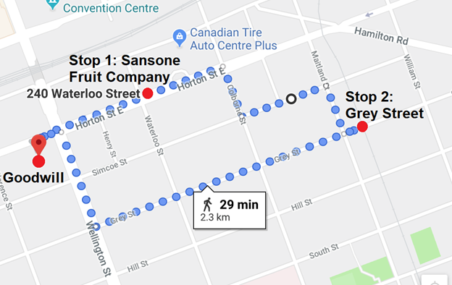

Introduction: This tour will focus on the theme of childhood through the eyes of an orphan. The tour features the childhood recollections of Jean Hough, who grew up in the neighbourhood after losing her parents at a young age. At times feeling at odds with her adoptive family, Jean looked to the wider community hoping to find a place to belong. We will take two stops at sites frequented by Jean, and hear her perspective on growing up in Soho. This tour is 2.3 km long and will take 40-45 minutes, including 29 minutes of walking in addition to time allowed to introduce and listen to the stories.

As we proceed through the tour, consider these questions. 1) When you think of your childhood neighbourhood, what stands out the most in your memory? If you moved around, is there a neighbourhood that stands out more than the others? Why? 2) Did you have a sense of a neighbourhood identity growing up? How would you describe it? 3) Do you associate a sense of “belonging” with your childhood neighbourhood(s)? 4) Has your neighbourhood(s) shaped your own sense of identity? How so?

Our first stop is the London Roundhouse, at the corner of Waterloo of Horton. We will walk (350 meters, 5 minutes) east along Horton street, crossing to the North side of the street at Wellington. Before we start, please take out your phones and enter the Hear Here number. (519-672-4327)

The London Roundhouse has served many functions since its original construction as a Michigan Central Railway roundhouse in the late nineteenth century. Around 1910, the railway no longer used the building and the Catalano Fruit Company moved in. Soon the Sansone Fruit Company took over became a major supplier of fruits and other produce until the 1970s.

Stop 1: Sansone provided the families of Soho with a source of fresh fruit and other produce. As a child Jean would visit the warehouse weekly, at first accompanying her adoptive sister, but once she was old enough she would walk there on her own and pick up ten pounds of bananas for the family.

Take out your phones now and call the Hear Here number. When promoted, say or dial “35”.

We will now walk (850 meters, 11 minutes) to our second stop at the Grey and Maitland train crossing. Heading south one block down Waterloo Street, we will then turn left onto Simcoe Street and walk two blocks to Maitland St, turn right and head south one block down Maitland, turn left onto Grey Street and stop just before the tracks.

Stop 2: Jean would often walk down Grey Street on early mornings in the summer, and took note of the diversity in her neighbourhood on these walks. As an orphan and adopted child, she struggled to find a sense of belonging and found comfort in this diversity.

Take out your phones now and call the Hear Here number. When promoted, say or dial When Jean’s story finishes, the phone will prompt you to carry on to the next story. Please hang up at this point, and we will continue on the final leg of our tour.

We will now head back to Goodwill (1.1 km, 14 minutes), heading three blocks west along Grey Street, crossing Wellington and turning right we will walk two blocks north to Goodwill. Walking along Grey Street, we will pass by some of the same houses Jean walked past, and you can imagine the smells she described filling the street on a hot summer’s morning.

Conclusion: Thank you for joining me on this tour. When I spoke with Jean, she stressed that she thought Soho was a wonderful place to grow up. She reflected herself that she turned outwards to her community, and because of that remembers the neighbourhood in a different way than her friends. While she did not find the sense of belonging she was looking for, she took comfort in the diversity of her neighbourhood, where she saw that belonging didn’t mean coming from the same roots. People could all come from their own unique backgrounds, and yet still accept and support one another.

Consider again some of the questions I posed at the beginning of our tour. , consider these questions. 1) Did you have a sense of a neighbourhood identity growing up? How would you describe it? 2) Do you associate a sense of “belonging” with your childhood neighbourhood(s)? 3) Has your neighbourhood(s) shaped your own sense of identity? How so?

Thank you for taking the time to join us today. I hope you have found the experience enjoyable and enlightening. There will be some closing remarks at Goodwill which you are welcome to stay for. If you have just joined us, there are many other stories to explore around the neighbourhood. Take a brochure and follow the map to the orange signs. Thank you!

